Social network analysis (SNA) is beyond analysis on feeds from sites like Facebook, Twitter, LinkedIn or Google Plus. Social network is a network of entities that have some form of connectivity between them, and these entities can include credit cards, companies, merchants, individuals, etc. It can include transactional data, such as online transactions and banking data, social media data, call behaviour data, IP address information, geospatial data etc., stored in unstructured formats in some persistence data stores.

It is very important that methods be sought for in order probe such large networks of relationships and establish suspicious patterns of behaviour

Traditional fraud detection methods concentrate on discrete data rather than the connections between them in an attempt to uncover deviations from normal or expected patterns. Although discrete methods are useful for catching fraudsters acting alone, they fall short in their ability to detect organized crime rings. Further, discrete methods are prone to false positives, which create undesired side effects in customer satisfaction and lost revenue opportunity.

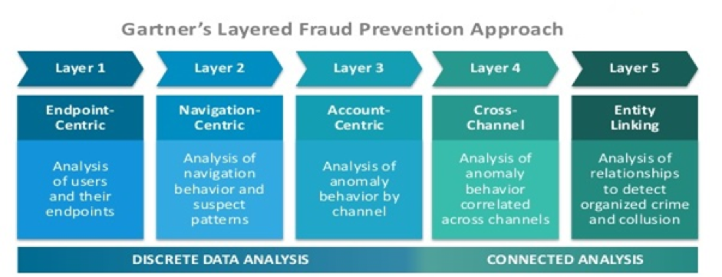

From the diagram above, the Entity Linking analysis leverages connectivity between data to detect fraud.

Graph database technology was designed specially to work with big datasets that have connections and relationships. Storing and retrieving interconnected information in a native ‘network graph’ format can deliver interactive network visualizations to discover hidden structures, locate clusters and patterns, identify links in transaction chains, and apply specialized algorithms to identify suspicious patterns.

NOSQL graph databases store and retrieve data in a native network format. Neo4J is a market leading graph database which can be rapidly implemented and is highly scalable. Advanced analytics methods such as machine learning are already applied to detect fraudulent transactions. Along with such analytical methods, SNA with graph databases can significantly reduce the false positive ratio in fraud detection.

<https://www.globalbankingandfinance.com/insurance-fraud-detection-are-we-ignoring-social-media-at-our-peril/>

<https://www.cio.com/article/2422376/fighting-fraud-with-social-network-analysis.html>